Name: Kadiyala Naresh

Rg.no.: 192110312

Course: object oriented C++

Code: DSA0163

**INT :**

#include <iostream>

using namespace std;

int main()

{

int n,i;

cout<<"enter the size: ";

cin>>n;

int *p=new int;

*p=n;

cout<<*p;

delete[]p;

return 0;

}

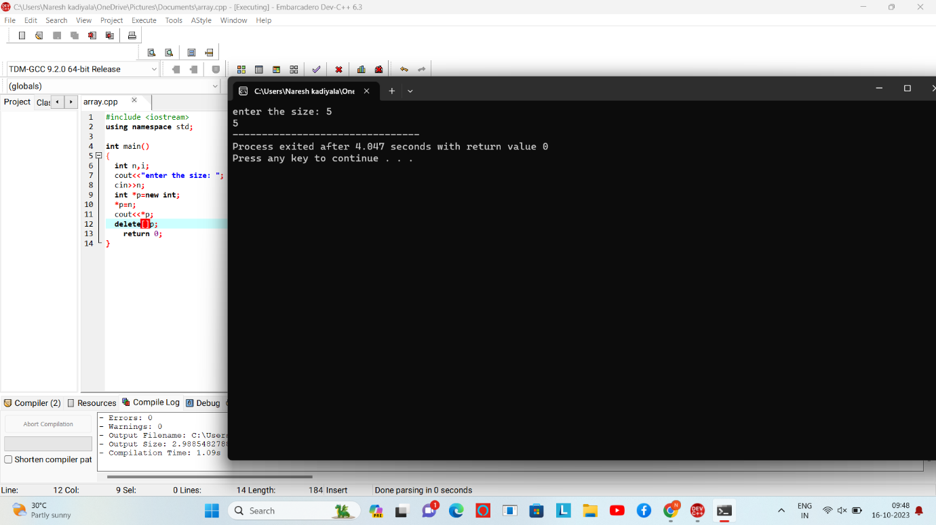

**FLOAT:**

#include <iostream>

using namespace std;

int main()

{

float n,i;

cout<<"enter the size: ";

cin>>n;

float *p=new float ;

*p=n;

cout<<*p;

delete p;

return 0;

}

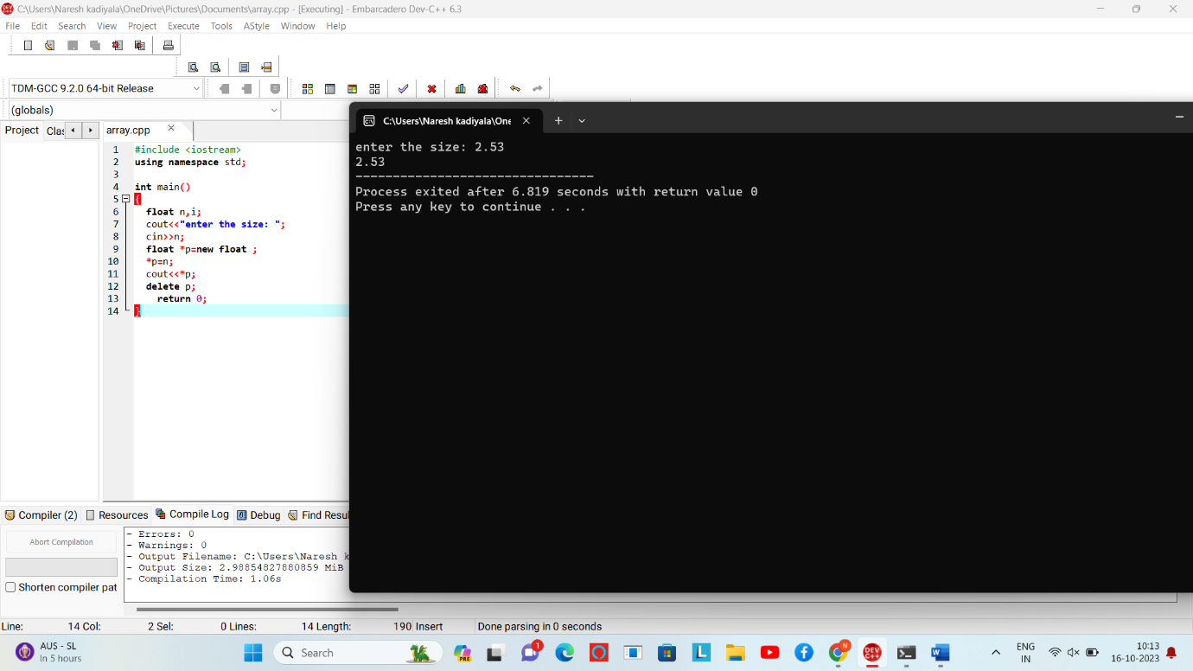

**DOUBLE**:

#include <iostream>

using namespace std;

int main()

{

double n,i;

cout<<"enter the size: ";

cin>>n;

double *p=new double;

*p=n;

cout<<*p;

delete p;

return 0;

}

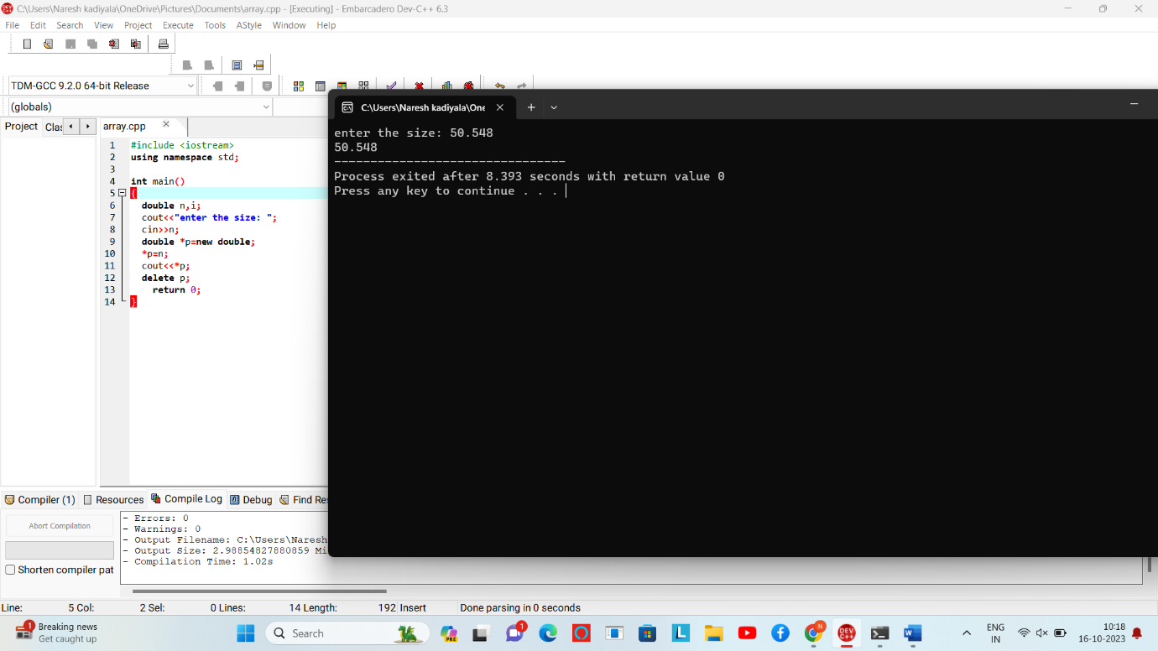

**Char:**

#include <iostream>

using namespace std;

int main()

{

char n,i;

cout<<"enter the size: ";

cin>>n;

char *p=new char;

*p=n;

cout<<*p;

delete p;

return 0;

}

